Strategy Recommendations & Observations
Based on the data analysis, I have developed two practical "rules of thumb" that could help traders on the platform improve their performance based on market sentiment.
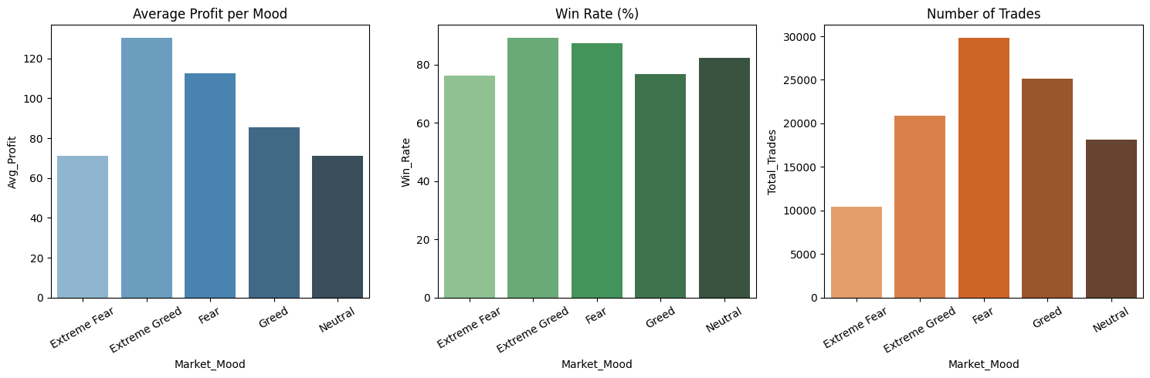
1. Profitable Trend
- Observation: According to the Win Rate chart, traders are most successful during Fear and Extreme Greed days, with win rates between 87% and 89%. These seem to be the most predictable times for users to make money.
- Recommendation: The platform should encourage more activity on these days. We could send a simple notification to keep users engaged when the data shows they are most likely to succeed.
2. Safety First
- Observation: There is a big drop in performance during Extreme Fear, where the win rate is falling to 76%. This is likely because traders start to panic and exit trades too early.
- Recommendation: On Extreme Fear days, the platform should prioritize user safety. We should suggest traders to lower their leverage or reduce the trade sizes. By sending a risk alert, this will help users protect their balance so they don't lose everything during a market crash.

